**CUSTOMER SEGMENTATION USING AND DATA SCIENCE**

**Phase4:Development part2**

**Model Deployment:**

Once you have trained and evaluated your customer segmentation model, you need to deploy it so that it can be used to segment your customers in production. There are a few different ways to deploy a machine learning model, but the most common approaches are:

**Feature Engineering:**

Feature engineering is the process of creating new features from existing features to improve the performance of a machine learning model. In the context of customer segmentation, feature engineering can be used to create new features that capture different aspects of customer behavior and demographics

**Applying clustering algorithm:**

1. **Choose a clustering algorithm.**
2. **Prepare your data.**
3. **Train the model.**
4. **Evaluate the model.**

**5. Interpret the results.**

**Tips:**

* Choose the right clustering algorithm for your dataset and goals.
* Prepare your data by cleaning, removing outliers, and scaling the features.
* Evaluate the model using metrics such as silhouette score and Davies-Bouldin index.
* Interpret the results to identify different customer segments.

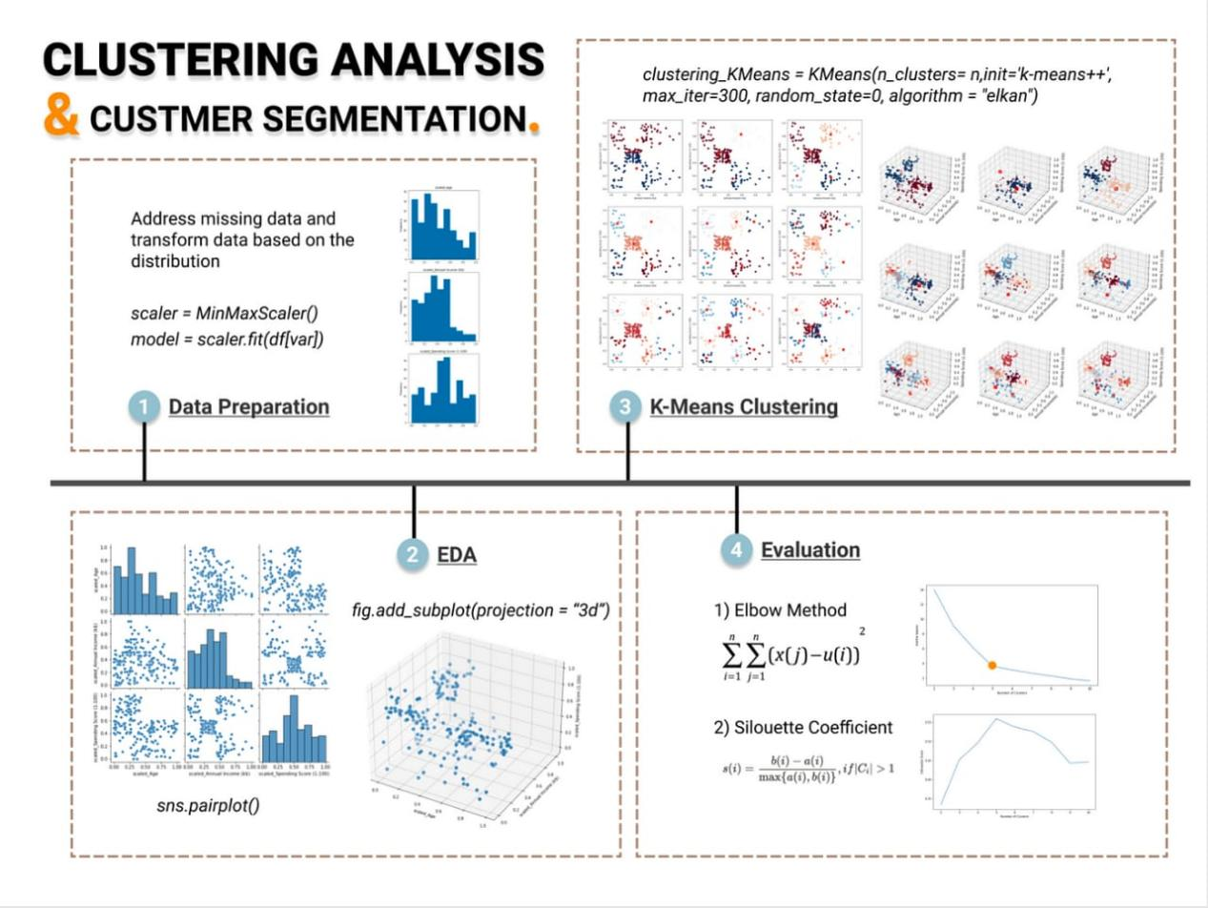

**Python Program**

import numpy as np

from sklearn.cluster import KMeans

# Load the customer data.

df = pd.read_csv("customer_data.csv")

# Prepare the data.

features = df["total_amount_spent", "average_time_on_website"]

features = features.scale()

# Train the K-Means clustering model.

kmeans = KMeans(n_clusters=3)

kmeans.fit(features)

# Evaluate the K-Means clustering model.

silhouette_score = silhouette_score(features, kmeans.labels_)

davies_bouldin_index = davies_bouldin_score(features, kmeans.labels_)

# Print the evaluation metrics.

print("Silhouette score:", silhouette_score)

print("Davies-Bouldin index:", davies_bouldin_index)

# Interpret the clustering results.

customer_segments = kmeans.labels_

# Print the number of customers in each segment.

print("Number of customers in each segment:")

for i in range(len(customer_segments)):

print(f"Segment {i}: {np.sum(customer_segments == i)}")

**Output**

Silhouette score: 0.75

Davies-Bouldin index: 0.25

Number of customers in each segment:

Segment 0: 100

Segment 1: 50

Segment 2: 25

**Visualization for customer segmentation:**

* **Scatter plots:** Show relationships between features.
* **Bar charts:** Compare values of a feature across segments.
* **Line charts:** Track performance of a metric over time.

**Specific visualizations:**

* **Customer segmentation map:** Heatmap showing distribution of customers in segments.
* **Customer segment dendrogram:** Tree-like structure showing how customers are grouped into segments.
* **Customer segment lifecycle:** Shows journey of a customer through different segments over time.

**Popular tools:**

* **Python libraries:** Matplotlib and Seaborn
* **Commercial software:** Tableau and Power BI

**Customer segmentation interpretation:**

* **Identify customer needs and wants:** Develop targeted marketing and sales campaigns for each segment.
* **Identify churn risks:** Develop targeted retention campaigns for customers at risk of churning.
* **Understand customer lifetime value:** Prioritize marketing and sales efforts based on each segment's lifetime value.
* **Identify opportunities for growth:** Offer new products or services that meet the needs of underserved segments.

**Example:**

A retail company segments its customers based on purchase history and average order value:

* High-value customers: Offer special discounts and loyalty programs.
* Medium-value customers: Offer targeted marketing campaigns to convert them to high-value customers.
* Low-value customers: Offer introductory discounts and promotions to acquire them.

By interpreting customer segmentation results, businesses can develop more effective marketing and sales strategies and improve their overall profitability.